**Welcome to Tree of Life Lutheran Church**

July 27, 2025 – Seventh Sunday After Pentecost

Leader in regular type, **congregation in bold type**

**↑** means stand as you are able

**Restrooms** are by the kitchen and by the Wiggle Room

**Wiggle Room** is available for anyone needing a brief break from worship, at the end of the piano wing of the sanctuary

**WiFi** is available: Look for TOL-GUEST; password is OdessaTOL1



**We Gather as God’s People**

**PRELUDE**

*You can use this time for quiet reflection, prayer and preparation for worship.*

**↑ CONFESSION AND FORGIVENESS**

In the name of the Father, and of the +Son, and of the Holy Spirit. **Amen.**

Baptized into Christ and trusting in his grace, let us confess our sins in the presence of God and one-another. *Silence for reflection.*

Most merciful God: **You free us to love others,** **but we neglect our neighbors and follow our own way.** **You lead us by the Spirit,** **but we turn to sin in our thoughts, words and deeds.** **You surround us with goodness, but we grow weary in doing what is right. For the sake of your Son Jesus Christ, forgive us.**

**Heal us and show us the path of life.** **Amen.**

You belong to Christ Jesus, and you are God’s children through faith. As a called and ordained minister of the church of Christ, and by his authority, I therefore declare to you the entire forgiveness of all your sins, in the name of the Father, and of the +Son, and of the Holy Spirit. **Amen.**

**↑ HYMN “The Power Of Your Love” BLACK BINDER #17**

**↑ APOSTOLIC GREETING**

The grace of our Lord Jesus Christ, the love of God, and the communion of the Holy Spirit be with you all. **And also with you.**

**↑ HYMN OF PRAISE “Lord, I Lift Your Name on High” ELW #857**

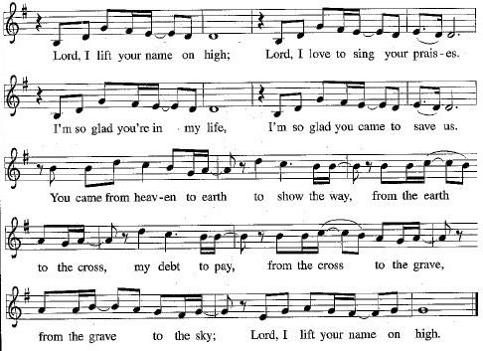

**↑ Prayer of the Day**

The Lord be with you. **And also with you.**

Let us pray: Almighty and ever-living God, you are always more ready to hear than we are to pray, and you gladly give more than we either desire or deserve. Pour upon us your abundant mercy. Forgive us those things that weigh on our conscience, and give us those good things that come only through your Son, Jesus Christ, our Savior and Lord. **Amen.**

**We Hear God’s Word**

**First Reading: Genesis 18:20-32**

A reading from Genesis:

20 Then the Lord said, “How great is the outcry against Sodom and Gomorrah and how very grave their sin! 21 I must go down and see whether they have done altogether according to the outcry that has come to me, and if not, I will know.”  
   22 So the men turned from there and went toward Sodom, while Abraham remained standing before the Lord. 23 Then Abraham came near and said, “Will you indeed sweep away the righteous with the wicked? 24 Suppose there are fifty righteous within the city; will you then sweep away the place and not forgive it for the fifty righteous who are in it? 25 Far be it from you to do such a thing, to slay the righteous with the wicked, so that the righteous fare as the wicked! Far be that from you! Shall not the Judge of all the earth do what is just?” 26 And the Lord said, “If I find at Sodom fifty righteous in the city, I will forgive the whole place for their sake.”

27 Abraham answered, “Let me take it upon myself to speak to my Lord, I who am but dust and ashes. 28 Suppose five of the fifty righteous are lacking? Will you destroy the whole city for lack of five?” And he said, “I will not destroy it if I find forty-five there.”

29 Again he spoke to him, “Suppose forty are found there.” He answered, “For the sake of forty I will not do it.” 30 Then he said, “Oh, do not let my Lord be angry if I speak. Suppose thirty are found there.” He answered, “I will not do it, if I find thirty there.” 31 He said, “Let me take it upon myself to speak to my Lord. Suppose twenty are found there.” He answered, “For the sake of twenty I will not destroy it.” 32 Then he said, “Oh, do not let my Lord be angry if I speak just once more. Suppose ten are found there.” He answered, “For the sake of ten I will not destroy it.”

The word of the Lord.

**Thanks be to God.**

**Psalm: Psalm 138**

1 I will give thanks to you, O Lord, with my whole heart;  
  before the gods I will sing your praise.  
2**I will bow down toward your holy temple and praise your name, because of**

**your steadfast love and faithfulness;  
  for you have glorified your name and your word above all things.**

3 When I called, you answered me; you increased my strength within me.  
4 **All the rulers of the earth will praise you, O Lord,  
  when they have heard the words of your mouth.**5 They will sing of the ways of the Lord, that great is the glory of the Lord.6**The Lord is high, yet cares for the lowly, perceiving the haughty from afar.**7 Though I walk in the midst of trouble, you keep me safe;  
  you stretch forth your hand against the fury of my enemies;

your right hand shall save me.  
8**You will make good your purpose for me; O Lord, your steadfast love**

**endures forever; do not abandon the works of your hands.**

**Second Reading: Colossians 2:6-19**

A reading from Colossians:

6 As you therefore have received Christ Jesus the Lord, continue to walk in him, 7 rooted and built up in him and established in the faith, just as you were taught, abounding in thanksgiving.  
   8 Watch out that no one takes you captive through philosophy and empty deceit, according to human tradition, according to the elemental principles of the world, and not according to Christ. 9 For in him the whole fullness of deity dwells bodily, 10 and you have come to fullness in him, who is the head of every ruler and authority. 11 In him also you were circumcised with a spiritual circumcision, by the removal of the body of the flesh in the circumcision of Christ; 12 when you were buried with him in baptism, you were also raised with him through faith in the power of God, who raised him from the dead. 13 And when you were dead in trespasses and the uncircumcision of your flesh, God made you alive together with him, when he forgave us all our trespasses, 14 erasing the record that stood against us with its legal demands. He set this aside, nailing it to the cross. 15 He disarmed the rulers and authorities and made a public example of them, triumphing over them in it.  
   16 Therefore, do not let anyone condemn you in matters of food or drink or of observing festivals, new moons, or Sabbaths. 17 These are only a shadow of what is to come, but the body belongs to Christ. 18 Do not let anyone disqualify you, insisting on self-abasement and worship of angels, initiatory visions, puffed up without cause by a human way of thinking, 19 and not holding fast to the head, from whom the whole body, nourished and held together by its ligaments and tendons, grows with a growth that is from God.

The word of the Lord.

**Thanks be to God.**

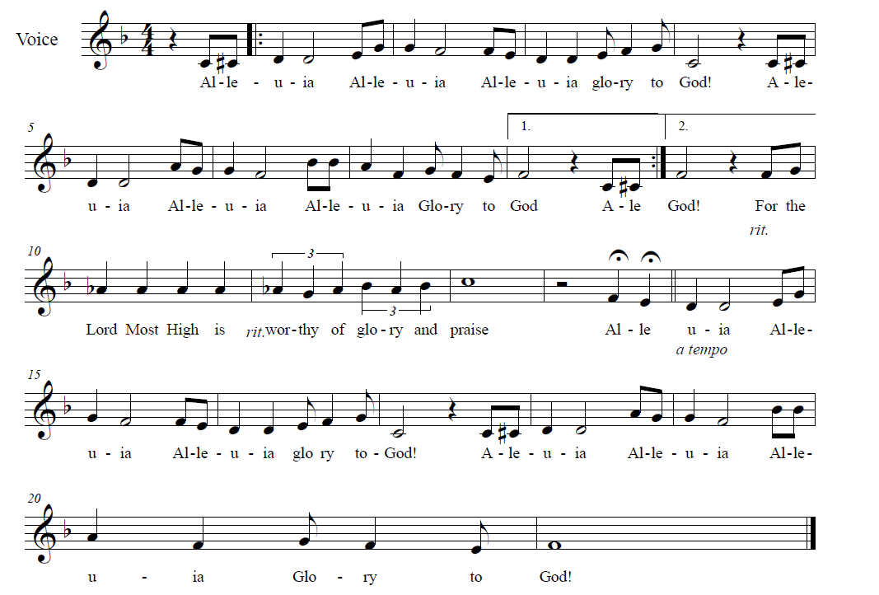**↑ GOSPEL ACCLAMATION** *Composed by D.D. Dillard*

**↑** **GOSPEL: Luke 11:1-13**

The holy gospel according to Luke.

**Glory to you, O Lord.**

1 [Jesus] was praying in a certain place, and after he had finished, one of his disciples said to him, “Lord, teach us to pray, as John taught his disciples.”

2 So he said to them, “When you pray, say: Father, may your name be revered as holy. May your kingdom come. 3 Give us each day our daily bread. 4 And forgive us our sins, for we ourselves forgive everyone indebted to us. And do not bring us to the time of trial.”  
   5 And he said to them, “Suppose one of you has a friend, and you go to him at midnight and say to him, ‘Friend, lend me three loaves of bread, 6 for a friend of mine has arrived, and I have nothing to set before him.’ 7 And he answers from within, ‘Do not bother me; the door has already been locked, and my children are with me in bed; I cannot get up and give you anything.’ 8 I tell you, even though he will not get up and give him anything out of friendship, at least because of his persistence he will get up and give him whatever he needs.  
   9 “So I say to you, Ask, and it will be given to you; search, and you will find; knock, and the door will be opened for you. 10 For everyone who asks receives, and everyone who searches finds, and for everyone who knocks, the door will be opened. 11 Is there anyone among you who, if your child asked for a fish, would give a snake instead of a fish? 12 Or if the child asked for an egg, would give a scorpion? 13 If you, then, who are evil, know how to give good gifts to your children, how much more will the heavenly Father give the Holy Spirit to those who ask him!”

The gospel of the Lord.

**Praise to you, O Christ.**

**CHILDREN’S SERMON**

**Sermon**

**↑ HYMN “Savior Like A Shepherd Lead Us” RED HYMNAL #789**

**We Welcome New Christians through Holy Baptism**

**PRESENTATION**

In Holy Baptism, our gracious heavenly Father liberates us from sin and death by joining us to the death and resurrection of our Lord Jesus Christ. We are born children of a fallen humanity; in the waters of Baptism, we are reborn children of God and inheritors of eternal life. By water and the Holy Spirit, we are made members of the Church, which is the body of Christ. As we live with Christ and with his people, we grow in faith, love, and obedience to the will of God.

Parents and sponsors, do you present Aubree Washington, Zavian Ashong and Zorelia Ashong for Holy Baptism?

*We do.*

Aubree, Zavian and Zorelia, called by the Holy Spirit and trusting in the grace and love of God, do you wish to be baptized today?

*I do.*

Chelsea, Nicole and Niiamah, as you bring these children to receive the gift of Baptism, you are entrusted with certain responsibilities:

to live with them among God's faithful people;

to bring them to the Word of God and the Holy Supper;

to teach them the Lord’s Prayer, the Creed and the Ten Commandments;

to place in their hands the Holy Scriptures;

and to nurture them in faith and prayer, so that they may learn to trust God,

proclaim Christ through word and deed, care for others and the world God made, and work for justice and peace.

Do you promise to help Aubree, Zavian and Zorelia grow in Christian faith and life?

*We do.*

Nicole, Niiamah, Chelsea, Aferba and Kwadwo: As the sponsors of these children, do you promise to nurture them in the Christian faith as you are empowered by the Holy Spirit, and to help them live in the covenant of Baptism and in communion with the Church?

*We do.*

People of God, do you promise to support Zavian, Zorelia and Aubree, and pray for them in their new life in Christ?

**We do.**

**PROFESSION OF FAITH**

Aubree, Zavian, Zorelia, parents and sponsors: I ask you now to profess your faith in Christ Jesus, reject sin, and confess the faith of the Church, the faith in which we baptize.

Do you renounce the devil and all the forces that defy God?

*I renounce them.*

Do you renounce the powers of this world that rebel against God?

*I renounce them.*

Do you renounce the ways of sin that draw you from God?

*I renounce them.*

Together with all the people of God, do you believe in God the Father?

**I believe in God, the Father almighty, creator of heaven and earth.**

Do you believe in Jesus Christ, the Son of God?

**I believe in Jesus Christ, his only Son, our Lord,** **who was conceived by the Holy Spirit, born of the virgin Mary,** **suffered under Pontius Pilate,** **was crucified, died, and was buried;** **and descended into hell.** **On the third day he rose again;** **he ascended into heaven,** **he is seated at the right hand of the Father,** **and he will come to judge the living and the dead.**

Do you believe in God the Holy Spirit?

**I believe in the Holy Spirit, the holy catholic Church, the communion of saints, the forgiveness of sins, the resurrection of the body, and the life everlasting.**

**THANKSGIVING AT THE FONT**

The Lord be with you.

**And also with you.**

Let us give thanks to the Lord our God.

**It is right to give our thanks and praise.**

Holy God, mighty Lord, gracious Father: We give you thanks, for in the beginning your Spirit moved over the waters, and you created heaven and earth. By the gift of water, you nourish and sustain us and all living things.

By the waters of the flood you condemned the wicked and saved those whom you had chosen, Noah and his family.

You led Israel by the pillar of cloud and fire through the sea, out of slavery into the freedom of the promised land.

In the waters of the Jordan, your Son was baptized by John and anointed with the Spirit.

By the baptism of his own death and resurrection, your beloved Son has set us free from the bondage to sin and death, and has opened the way to the joy and freedom of everlasting life.

He made water a sign of the Kingdom and of cleansing and rebirth. In obedience to his command, we make disciples of all nations, baptizing them in the name of the Father, and of the Son, and of the Holy Spirit.

Pour out your Holy Spirit, so that those who are here baptized may be given new life. Wash away the sin of all those who are cleansed by this water and bring them forth as inheritors of your glorious kingdom.

To you be given praise and honor and worship through your Son, Jesus Christ our Lord, in the unity of the Holy Spirit, now and forever.

**Amen.**

**BAPTISM**

Aubree Jayde, you are baptized in the name of the Father, and of the Son, and of the Holy Spirit. **Amen.**

Zavian Gyateh, you are baptized in the name of the Father, and of the Son, and of the Holy Spirit. **Amen.**

Zorelia Dedei, you are baptized in the name of the Father, and of the Son, and of the Holy Spirit. **Amen.**

**BLESSING**

Let us pray: We give you thanks, O God, that through water and the Holy Spirit, you give your daughters and sons new birth, cleanse them from sin, and raise them to eternal life. Pour out your Holy Spirit upon Zorelia, Zavian and Aubree: the spirit of wisdom and understanding, the spirit of counsel and might, the spirit of knowledge and the fear of the Lord, the spirit of joy in your presence, both now and forever.

**Amen.**

**ANOINTING**

Aubree, child of God, you have been sealed by the Holy Spirit and marked with the cross of Christ forever. **Amen.**

Zavian, child of God, you have been sealed by the Holy Spirit and marked with the cross of Christ forever. **Amen.**

Zorelia, child of God, you have been sealed by the Holy Spirit and marked with the cross of Christ forever. **Amen.**

**PRAYER FOR THE FAMILIES**

O God, the giver of all life, look with kindness upon the parents of Zorelia, Zavian and Aubree, and all their extended family and sponsors. Let them ever rejoice in the gift you have given them. Make them teachers and examples of righteousness for their children. Strengthen them in their own Baptism, that they may rejoice eternally with their children in the salvation you have given them, through Jesus Christ our Lord. **Amen.**

**WELCOME**

*The acolyte or assisting minister lights a candle for each child from the Paschal Candle, gives it to a parent or sponsor, and says:*

Let your light so shine before others that they may see your good works and glorify your Father in heaven.

*The assisting minister or acolyte continues:*

Let us welcome the newly baptized:

**We welcome you into the Lord’s family. We receive you as fellow members of the body of Christ, children of the same heavenly Father, and workers with us in the Kingdom of God. Join us in giving thanks and praise to God, and bearing God's creative and redeeming Word to all the world.**

*The pastor introduces the newly baptized. The congregation may offer acclamation with applause, and the families return to their seats.*

**↑ PRayers of Intercession**

By the power of the Holy Spirit, let us pray for the Church, the world, and all people according to their needs:

Loving God and Father of all, you make us your own in Baptism, you hear us when we pray, and you bless us with the gifts of the Holy Spirit. Be with Aubree, Zavian and Zorelia in their new lives as baptized Christians, and support their families and friends. Grant that all who have been baptized into your Son may serve you in unity and peace. God of grace… **Hear our prayer.**

You give bread from the earth and water from the skies. Help us be good caretakers of the world you have entrusted to us, so that all your creatures might receive what they need. Support those affected by flood, storm, extreme heat, drought or other natural disaster. God of grace… **Hear our prayer.**

Your Kingdom rules over all earthly realms. Bless our country and those who serve it, so that your freedom, justice and peace might be known among us. God of grace… **Hear our prayer.**

You promise to help us whenever we cry to you. Help everyone who prays to you with needs of body, mind or spirit. We especially pray for Annalise, Bill, Bob, Chris, Dan, Danielle, Dot, Elizabeth, Erika, Noretta, Patrick, Paul, Sarah, William, Winnie and those we name with our lips or in our hearts… *(Time for personal petitions)* God of grace… **Hear our prayer.**

You forgive our sins and strengthen us to forgive those who sin against us. Grant that Tree of Life might be a place of grace and mercy, discipleship and service, prayer and praise, witness and worship. Bless our bishops, Elizabeth and William; our pastor, Robbie; and St. Andrew’s Lutheran Church and its pastor, Anne. God of grace… **Hear our prayer.**

You raise us to new and eternal life through our Baptism into Christ. We give you thanks for all who have gone before us. May we trust your steadfast love and continue in hope until we are united with all your saints. God of grace…

**Hear our prayer.**

We lift up these and all our prayers to you, O Lord, in the name of Jesus Christ, our Savior and Lord. **Amen.**

**↑ Peace**

The peace of Christ be with you always***.* And also with you.**

**We Share God’s Holy Meal**

**OFFERING “His Eye is On the Sparrow” Martin & Gabriel**

*Pam Nichols, voice; Duane Dillard, piano*

**↑ OFFERTORY RED HYMNAL #884**

**Praise God, from whom all blessings flow;**

**Praise Him, all creatures here below;**

**Praise Him above, ye Heav’nly host;**

**Praise Father, Son and Holy Ghost**

**↑ Offering Prayer**

Let us pray together: **Holy God, gracious and merciful, you bring forth food from the earth and nourish your whole creation. Turn our hearts toward those who hunger in any way, that all may know your care. Prepare us now to feast on the bread of life, Jesus Christ, our Savior and Lord. Amen.**

**↑ great thanksgiving**

*The thanksgiving continues with the preface for the day. The congregation responds:*

**↑ SANCTUS** *Composed by D.D. Dillard*

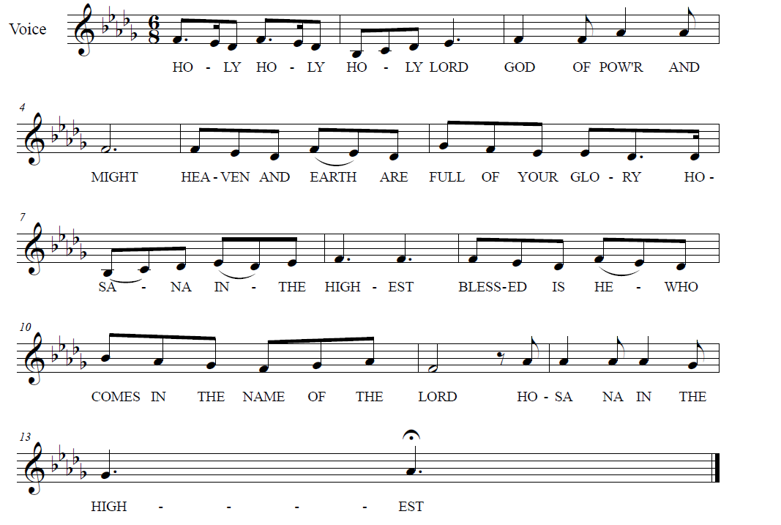

**

**↑ EUCHARISTIC PRAYER & WORDS OF INSTITUTION**

In the night in which he was betrayed, our Lord Jesus took bread, and gave thanks; broke it, and gave it to his disciples, saying: Take and eat; this is my body, given for you. Do this for the remembrance of me.

Again, after supper, he took the cup, gave thanks, and gave it for all to drink, saying: This cup is the new covenant in my blood, shed for you and for all people for the forgiveness of sin. Do this for the remembrance of me.

**↑ LORD’S PRAYER**

**Our Father, who art in heaven, hallowed be thy name,**

**thy kingdom come, thy will be done, on earth as it is in heaven.**

**Give us this day our daily bread.**

**And forgive us our trespasses, as we forgive those who trespass against us.**

**And lead us not into temptation, but deliver us from evil.**

**For thine is the kingdom, and the power, and the glory, forever and ever. Amen.**

**↑ INVITATION TO COMMUNION**

The gifts of God for the people of God.

**Thanks be to God.**

*All baptized Christians are welcome to commune. Wine and white grape juice are in the individual cups. Gluten-free wafers are available upon request.*

**COMMUNION** *Composed by D.D. Dillard*

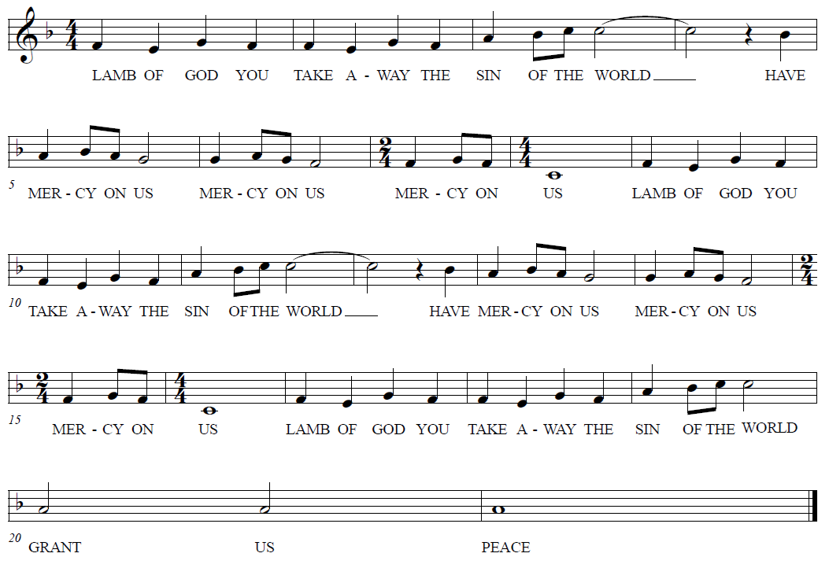

**HYMNS “One Bread One Body” RED HYMNAL #496**

**“Bread Of Life From Heaven” RED HYMNAL #474**

**Prayer after Communion**

Let us pray together: **Holy Lord, you gathered us to your table, and we drank deeply of your grace. Send us out by your Spirit to love our neighbors as ourselves and proclaim your love in Jesus’ name. Amen.**

**God Sends Us in Mission**

**Announcements**

**↑ Benediction**

The Lord bless you and keep you. The Lord’s face shine upon you and be gracious to you. The Lord look upon you with favor and ☩ give you peace. **Amen.**

**↑ HYMN** **“Go My Children With My Blessing” RED HYMNAL #543**

**↑ MISSION STATEMENT**

What is our Mission? **To be faithful children of God, called by grace through Christ, and sharing this gift with Middletown, Odessa, Townsend and the World.**

**↑ Dismissal**

Go in peace; serve the Lord!

**Thanks be to God!**

**POSTLUDE**

*You may listen to the music or depart to do God’s work.*

*Please join us for refreshments in the fellowship room after the service.*

From Sundays and Seasons.com. Copyright 2025 Augsburg Fortress. All rights reserved.

Reprinted by permission under Augsburg Fortress Liturgies Annual License #28947.New Revised Standard Version Bible, copyright 1989, Division of Christian Education of the National Council of the Churches of Christ in the United States of America. Used by permission. All rights reserved.

**Church Responses to the Flooding in Texas**

**Short-term relief: Southwestern Texas Synod Disaster Fund**

Online: SWTSynod.org

Mail: Southwestern Texas Synod; 1090 Oestreich Dr.; Seguin, TX 78155

**Long-term recovery: Lutheran Disaster Response**

Online: ELCA.org/LDR

Phone: 800-638-3522

Mail: Lutheran Disaster Response; P.O. Box 1809; Merrifield, VA 22116-8009

*Gifts to “U.S. Flooding” will be used in full (100%) to assist those affected by floods.*

**Matching Funds for Thrivent Members**

*Thrivent Financial is boosting donations made through its online-giving platform. For every $2 given through its platform to Austin Disaster Relief Network, Convoy of Hope, or Texas Search and Rescue, Thrivent will add $1 up to a total of $250,000. Thrivent will also pay the processing fees, so 100% will go directly to the cause.*

Online: Thrivent.com/about-us/membership/disaster-response#personal-donations

**Upcoming Happenings**

**Sunday, August 3**

“Hymn-Sing Sundae”

Hymn-based worship and ice cream social

**Sunday, August 10**

Blessing of the Backpacks

to support Appoquinimink students

**Sunday, August 24**

Worship with Sacrament of Holy Baptism

for Olivia Breighner Castelló