**Welcome to Tree of Life Lutheran Church**

July 20, 2025 – Sixth Sunday After Pentecost

Leader in regular type, **congregation in bold type**

**↑** means stand as you are able

**Restrooms** are by the kitchen and by the Wiggle Room

**Wiggle Room** is available for anyone needing a brief break from worship, at the end of the piano wing of the sanctuary

**WiFi** is available: Look for TOL-GUEST; password is OdessaTOL1



**We Gather as God’s People**

**PRELUDE**

*You can use this time for quiet reflection, prayer and preparation for worship.*

**↑ CONFESSION AND FORGIVENESS**

In the name of the Father, and of the +Son, and of the Holy Spirit. **Amen.**

Baptized into Christ and trusting in his grace, let us confess our sins in the presence of God and one-another. *Silence for reflection.*

Most merciful God: **You free us to love others,** **but we neglect our neighbors and follow our own way.** **You lead us by the Spirit,** **but we turn to sin in our thoughts, words and deeds.** **You surround us with goodness, but we grow weary in doing what is right. For the sake of your Son Jesus Christ, forgive us.**

**Heal us and show us the path of life.** **Amen.**

You belong to Christ Jesus, and you are God’s children through faith. As a called and ordained minister of the church of Christ, and by his authority, I therefore declare to you the entire forgiveness of all your sins, in the name of the Father, and of the +Son, and of the Holy Spirit. **Amen.**

**↑ HYMN “Lord Speak To Us That We May Speak” RED HYMNAL #626**

**↑ APOSTOLIC GREETING**

The grace of our Lord Jesus Christ, the love of God, and the communion of the Holy Spirit be with you all. **And also with you.**

**↑ HYMN OF PRAISE “Lord, I Lift Your Name on High” ELW #857**

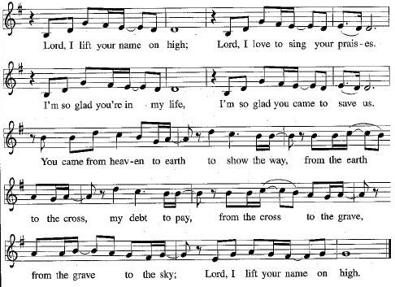

**↑ Prayer of the Day**

The Lord be with you. **And also with you.**

Let us pray: Eternal God, you draw near to us in Christ, and you make yourself our guest. Amid the cares of our lives, make us attentive to your presence, that we may treasure your Word above all else, through Jesus Christ, our Savior and Lord. **Amen.**

**We Hear God’s Word**

**First Reading: Genesis 18:1-10a**

A reading from Genesis:

1The Lord appeared to Abraham by the oaks of Mamre, as he sat at the entrance of his tent in the heat of the day. 2He looked up and saw three men standing near him. When he saw them, he ran from the tent entrance to meet them and bowed down to the ground. 3He said, “My lord, if I find favor with you, do not pass by your servant. 4Let a little water be brought, and wash your feet, and rest yourselves under the tree. 5Let me bring a little bread, that you may refresh yourselves, and after that you may pass on — since you have come to your servant.” So they said, “Do as you have said.”

6And Abraham hastened into the tent to Sarah and said, “Make ready quickly three measures of choice flour, knead it, and make cakes.” 7Abraham ran to the herd and took a calf, tender and good, and gave it to the servant, who hastened to prepare it. 8Then he took curds and milk and the calf that he had prepared and set it before them, and he stood by them under the tree while they ate.  
   9They said to him, “Where is your wife Sarah?” And he said, “There, in the tent.” 10aThen one said, “I will surely return to you in due season, and your wife Sarah shall have a son.”

The word of the Lord.

**Thanks be to God.**

**Psalm: Psalm 15**

1 Lord, who may dwell in your tabernacle?  
  Who may abide upon your holy hill?  
**2 Those who lead a blameless life and do what is right,  
  who speak the truth from their heart;**3 they do not slander with the tongue, they do no evil to their friends;  
  they do not cast discredit upon a neighbor.  
**4 In their sight the wicked are rejected, but they honor those who fear the**

**Lord. They have sworn upon their health and do not take back their word.**5 They do not give their money in hope of gain,

nor do they take bribes against the innocent.

**Those who do these things shall never be overthrown.**

**Second Reading: Colossians 1:15-28**

A reading from Colossians:

15 [Christ Jesus] is the image of the invisible God, the firstborn of all creation, 16for in him all things in heaven and on earth were created, things visible and invisible, whether thrones or dominions or rulers or powers — all things have been created through him and for him. 17 He himself is before all things, and in him all things hold together. 18 He is the head of the body, the church; he is the beginning, the firstborn from the dead, so that he might come to have first place in everything. 19 For in him all the fullness of God was pleased to dwell, 20 and through him God was pleased to reconcile to himself all things, whether on earth or in heaven, by making peace through the blood of his cross.  
   21 And you who were once estranged and hostile in mind, doing evil deeds, 22 he has now reconciled in his fleshly body through death, so as to present you holy and blameless and irreproachable before him, 23 provided that you continue securely established and steadfast in the faith, without shifting from the hope promised by the gospel that you heard, which has been proclaimed to every creature under heaven.   
I, Paul, became a minister of this gospel.  
   24 I am now rejoicing in my sufferings for your sake, and in my flesh I am completing what is lacking in Christ’s afflictions for the sake of his body, that is, the church. 25 I became its minister according to God’s commission that was given to me for you, to make the word of God fully known, 26 the mystery that has been hidden throughout the ages and generations but has now been revealed to his saints. 27 To them God chose to make known how great among the gentiles are the riches of the glory of this mystery, which is Christ in you, the hope of glory. 28 It is he whom we proclaim, warning everyone and teaching everyone in all wisdom, so that we may present everyone mature in Christ.

The word of the Lord.

**Thanks be to God.**

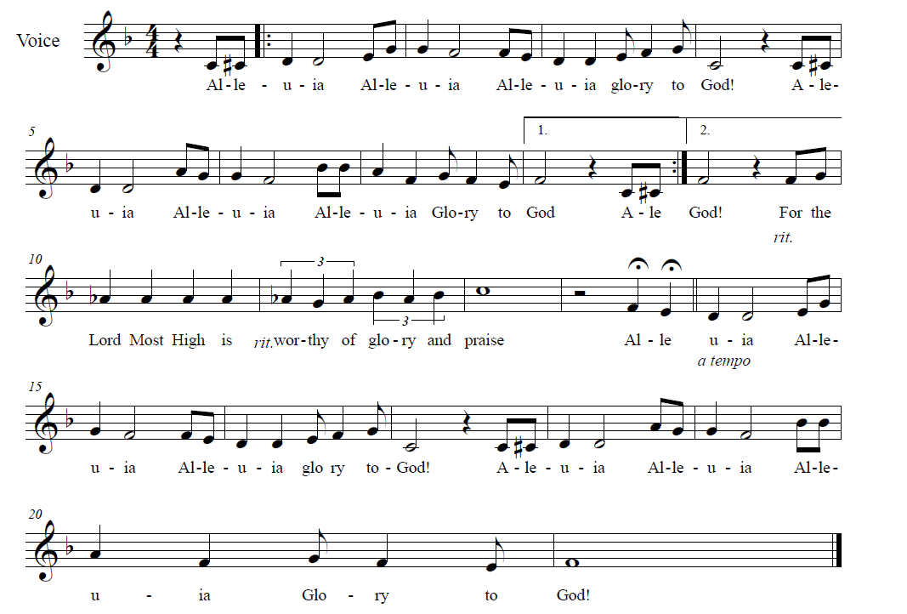**↑ GOSPEL ACCLAMATION** *Composed by D.D. Dillard*



**↑** **GOSPEL: Luke 10:38-42**

The holy gospel according to Luke.

**Glory to you, O Lord.**

38 Now as [Jesus and his disciples] went on their way, he entered a certain village where a woman named Martha welcomed him. 39 She had a sister named Mary, who sat at Jesus’s feet and listened to what he was saying. 40 But Martha was distracted by her many tasks, so she came to him and asked, “Lord, do you not care that my sister has left me to do all the work by myself? Tell her, then, to help me.” 41 But the Lord answered her, “Martha, Martha, you are worried and distracted by many things, 42 but few things are needed — indeed only one. Mary has chosen the better part, which will not be taken away from her.”

The gospel of the Lord.

**Praise to you, O Christ.**

**CHILDREN’S SERMON**

**Sermon**

**↑ HYMN “Take My Life That I May Be” RED HYMNAL #685**

**↑ APOSTLES’ CREED**

**I believe in God, the Father almighty, creator of heaven and earth.**

**I believe in Jesus Christ, his only Son, our Lord,**

**who was conceived by the Holy Spirit, born of the virgin Mary,**

**suffered under Pontius Pilate,** **was crucified, died, and was buried;**

**and descended into hell.**

**On the third day he rose again;** **he ascended into heaven,**

**he is seated at the right hand of the Father,**

**and he will come to judge the living and the dead.**

**I believe in the Holy Spirit,**

**the holy catholic Church,** **the communion of saints,**

**the forgiveness of sins,** **the resurrection of the body,**

**and the life everlasting. Amen.**

**↑ PRayers of Intercession**

By the power of the Holy Spirit, let us pray for the Church, the world, and all people according to their needs:

Eternal God and Father of all, you come to us with the Word of life. Grant that your Church in all times and places may unite in your name, listen to your words, follow your way and witness to your goodness. God of grace… **Hear our prayer.**

All things are held together in the majesty of your Son. Bring life and growth to all the earth. Help those affected by fire, storm, flood or other natural disaster. Provide food in abundance for all people and all creatures. God of grace… **Hear our prayer.**

Your Son rules over thrones, dominions, rulers and powers. Bless our nation and all who lead it, and guide us in your ways of freedom, justice and peace. God of grace… **Hear our prayer.**

You visit the poor, the lowly, the suffering and the sick. Be with anyone who calls out to you with needs of body, mind or spirit. We especially pray for Annalise, Bill, Bob, Chris, Dan, Danielle, Dot, Elizabeth, Erika, Noretta, Patrick, Paul, Sarah, William, Winnie and those we name with our lips or in our hearts… *(Time for personal petitions)* God of grace… **Hear our prayer.**

You call Tree of Life to practice both the loving hospitality of Martha and the loving listening of Mary. Help us to hear the Good News of your love, and to share that love with others in your name. Bless our bishops, Elizabeth and William; our pastor, Robbie; Hope Lutheran Church and its interim pastor, Wes; and Lutheran Community Services. God of grace… **Hear our prayer.**

Your Son has reconciled us to you through the cross, so that we may know the assurance of eternal life. Accept our thanksgiving for all the saints who have gone before us, and sustain us in the sure hope in the resurrection. God of grace…

**Hear our prayer.**

We lift up these and all our prayers to you, O Lord, in the name of Jesus Christ, our Savior and Lord. **Amen.**

**↑ Peace**

The peace of Christ be with you always***.* And also with you.**

**We Share God’s Holy Meal**

**OFFERING**

**↑ OFFERTORY RED HYMNAL #884**

**Praise God, from whom all blessings flow;**

**Praise Him, all creatures here below;**

**Praise Him above, ye Heav’nly host;**

**Praise Father, Son and Holy Ghost**

**↑ Offering Prayer**

Let us pray together: **Holy God, gracious and merciful, you bring forth food from the earth and nourish your whole creation. Turn our hearts toward those who hunger in any way, that all may know your care. Prepare us now to feast on the bread of life, Jesus Christ, our Savior and Lord. Amen.**

**↑ great thanksgiving**

*The thanksgiving continues with the preface for the day. The congregation responds:*

**↑ SANCTUS**

*Composed by D.D. Dillard*

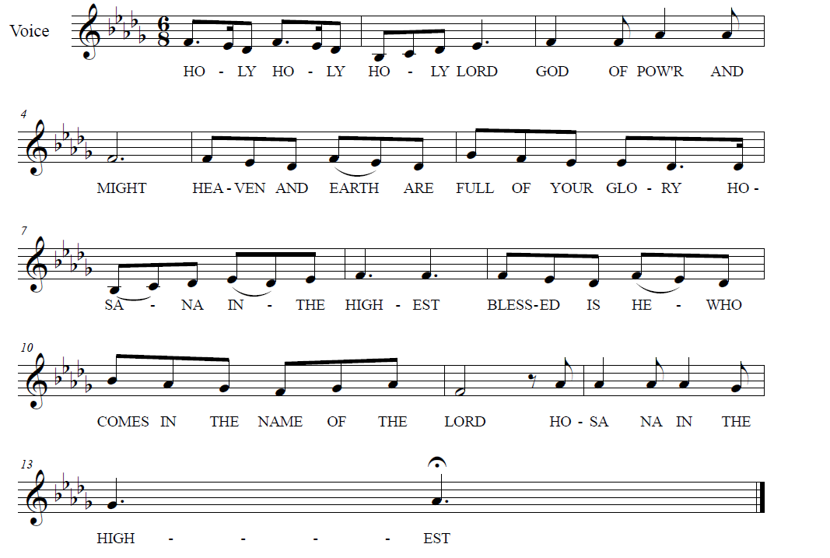

**

**↑ EUCHARISTIC PRAYER & WORDS OF INSTITUTION**

In the night in which he was betrayed, our Lord Jesus took bread, and gave thanks; broke it, and gave it to his disciples, saying: Take and eat; this is my body, given for you. Do this for the remembrance of me.

Again, after supper, he took the cup, gave thanks, and gave it for all to drink, saying: This cup is the new covenant in my blood, shed for you and for all people for the forgiveness of sin. Do this for the remembrance of me.

**↑ LORD’S PRAYER**

**Our Father, who art in heaven, hallowed be thy name,**

**thy kingdom come, thy will be done, on earth as it is in heaven.**

**Give us this day our daily bread.**

**And forgive us our trespasses, as we forgive those who trespass against us.**

**And lead us not into temptation, but deliver us from evil.**

**For thine is the kingdom, and the power, and the glory, forever and ever. Amen.**

**↑ INVITATION TO COMMUNION**

The gifts of God for the people of God.

**Thanks be to God.**

*All baptized Christians are welcome to commune. Wine and white grape juice are in the individual cups. Gluten-free wafers are available upon request.*

**COMMUNION** *Composed by D.D. Dillard*

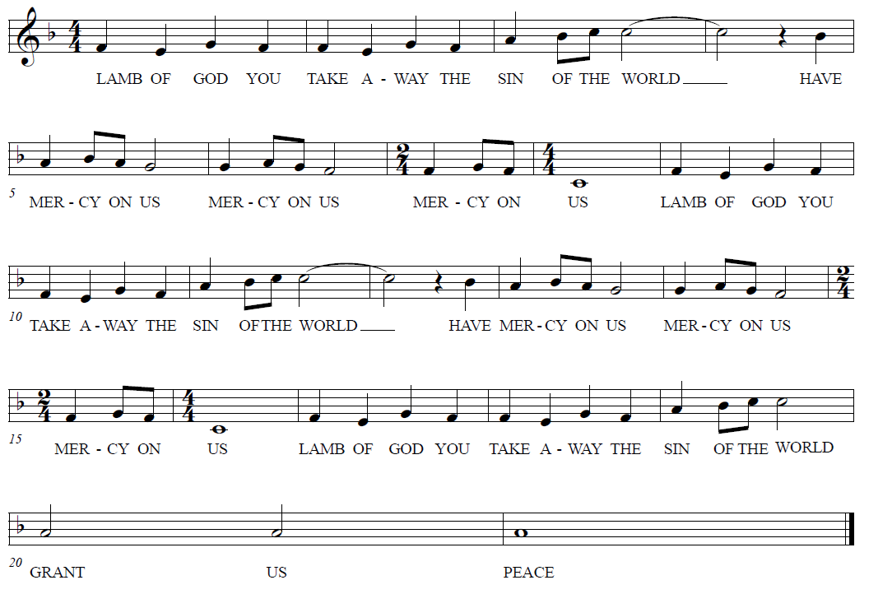

**HYMNS “One Bread One Body” RED HYMNAL #496**

**“Bread Of Life From Heaven” RED HYMNAL #474**

**Prayer after Communion**

Let us pray together: **Holy Lord, you gathered us to your table, and we drank deeply of your grace. Send us out by your Spirit to love our neighbors as ourselves and proclaim your love in Jesus’ name. Amen.**

**God Sends Us in Mission**

**Announcements**

**↑ Benediction**

The Lord bless you and keep you. The Lord’s face shine upon you and be gracious to you. The Lord look upon you with favor and ☩ give you peace. **Amen.**

**↑ HYMN** **“I’ll Fly Away” BLACK BINDER #32**

**↑ MISSION STATEMENT**

What is our Mission? **To be faithful children of God, called by grace through Christ, and sharing this gift with Middletown, Odessa, Townsend and the World.**

**↑ Dismissal**

Go in peace; serve the Lord!

**Thanks be to God!**

**POSTLUDE**

*You may listen to the music or depart to do God’s work.*

*Please join us for refreshments in the fellowship room after the service.*

From Sundays and Seasons.com. Copyright 2025 Augsburg Fortress. All rights reserved.

Reprinted by permission under Augsburg Fortress Liturgies Annual License #28947.New Revised Standard Version Bible, copyright 1989, Division of Christian Education of the National Council of the Churches of Christ in the United States of America. Used by permission. All rights reserved.

**Church Responses to the Flooding in Texas**

**Short-term relief: Southwestern Texas Synod Disaster Fund**

Online: SWTSynod.org

Mail: Southwestern Texas Synod; 1090 Oestreich Dr.; Seguin, TX 78155

**Long-term recovery: Lutheran Disaster Response**

Online: ELCA.org/LDR

Phone: 800-638-3522

Mail: Lutheran Disaster Response; P.O. Box 1809; Merrifield, VA 22116-8009

*Gifts to “U.S. Flooding” will be used in full (100%) to assist those affected by floods.*

**Matching Funds for Thrivent Members**

*Thrivent Financial is boosting donations made through its online-giving platform. For every $2 given through its platform to Austin Disaster Relief Network, Convoy of Hope, or Texas Search and Rescue, Thrivent will add $1 up to a total of $250,000. Thrivent will also pay the processing fees, so 100% will go directly to the cause.*

Online: Thrivent.com/about-us/membership/disaster-response#personal-donations

**Upcoming Happenings**

**Sunday, July 27**

Worship with Sacrament of Holy Baptism

for Aubree Washington, Zavian Ashong and Zorelia Ashong

**Sunday, August 3**

“Hymn-Sing Sundae:”

Hymn-based worship and ice cream social!

**Sunday, August 10**

Blessing of the Backpacks

to support Appoquinimink students