**Welcome to Tree of Life Lutheran Church**

August 3, 2025 – Eighth Sunday After Pentecost

Leader in regular type, **congregation in bold type**

**↑** means stand as you are able

**Restrooms** are by the kitchen and by the Wiggle Room

**Wiggle Room** is available for anyone needing a brief break from worship, at the end of the piano wing of the sanctuary

**WiFi** is available: Look for TOL-GUEST; password is OdessaTOL1



**We Gather as God’s People**

**PRELUDE**

*You can use this time for quiet reflection, prayer and preparation for worship.*

**WELCOME**

**↑ HYMN “Oh, for a Thousand Tongues to Sing” RED HYMNAL #886**

**↑ INVOCATION AND PSALM 98**

In the name of the Father, and the +Son, and the Holy Spirit.

**Amen.**

Sing to the Lord a new song, for He has done marvelous things!

**His right hand and His holy arm have gotten Him victory.**

The Lord has made known His victory;

He has revealed His righteousness in the sight of the nations.

**He has remembered his steadfast love and faithfulness to the house of Israel.**

**All the ends of the earth have seen the victory of our God.**

Make a joyful noise to the Lord, all the earth;

Break forth into joyous song and sing praises.

**Sing praises to the Lord with the lyre, with the lyre and the sound of melody.**

**With trumpets and the sound of the horn**

**make a joyful noise before the King, the Lord.**

Let the sea roar, and all that fills it; the world and those who live in it.

**Let the floods clap their hands; let the hills sing together for joy**

**at the presence of the Lord, for he is coming to judge the earth.**

**He will judge the world with righteousness, and the peoples with equity.**

Sing to the Lord a new song, for He has done marvelous things!

**His right hand and His holy arm have gotten Him victory.**

**↑ HYMN “Glorious Things of You are Spoken” RED HYMNAL #647**

**↑ Prayer of the Day**

The Lord be with you. **And also with you**.

Let us pray: Benevolent God, you are the source, the guide, and the goal of our lives. Teach us to love what is worth loving, to reject what is offensive to you, and to treasure what is precious in your sight, through Jesus Christ, our Savior and Lord. **Amen**.

**HYMN “Shout to the Lord” RED HYMNAL #821**

**We Hear God’s Word**

**FIRST READING: Ecclesiastes 1:2, 12-14; 2:18-23**

A reading from Ecclesiastes:

2 Vanity of vanities, says the Teacher, vanity of vanities! All is vanity.

12 I, the Teacher, was king over Israel in Jerusalem. 13 I applied my mind to seek and to search out by wisdom all that is done under heaven; it is an unhappy business that God has given to humans to be busy with. 14 I saw all the deeds that are done under the sun, and see, all is vanity and a chasing after wind.

2:18 I hated all my toil in which I had toiled under the sun, seeing that I must leave it to my successor, 19 and who knows whether he will be wise or foolish? Yet he will be master of all for which I toiled and used my wisdom under the sun. This also is vanity.

20 So I turned and gave my heart up to despair concerning all the toil of my labors under the sun, 21 because sometimes one who has toiled with wisdom and knowledge and skill must leave all to be enjoyed by another who did not toil for it. This also is vanity and a great evil. 22 What do mortals get from all the toil and strain with which they toil under the sun? 23 For all their days are full of pain, and their work is a vexation; even at night their minds do not rest. This also is vanity.

The word of the Lord.

**Thanks be to God.**

**HYMN “The Power of Your Love” BLACK BINDER #17**

**PSALM:  Psalm 49:1-12**

1 Hear this, all you peoples; give ear, all you who dwell in the world,  
 2 **you of high degree and low,** **rich and poor together.**  
 3 My mouth shall speak of wisdom, and my heart shall meditate on understanding.  
 4 **I will incline my ear to a proverb** **and set forth my riddle upon the harp.**  
 5 Why should I be afraid in evil days,  
  when the wickedness of those at my heels surrounds me,  
 6 **the wickedness of those who put their trust in their own prowess,**  
  **and boast of their great riches?**  
 7 One can never redeem another, or give to God the ransom for another’s life;  
 8 **for the ransom of a life is so great**  
  **that there would never be enough to pay it,**  
 9 in order to live forever and ever and never see the grave.  
 10 **For we see that the wise die also; like the dull and stupid they perish**  
  **and leave their wealth to those who come after them.**  
 11 Their graves shall be their homes forever,

their dwelling places from generation to generation,  
  though they had named lands after themselves.  
 12 **Even though honored, they cannot live forever;**  
  **they are like the beasts that perish.**

**HYMN “I’m So Glad Jesus Lifted Me” RED HYMNAL #860**

**SECOND READING: Colossians 3:1-11**

A reading from Colossians:

1 So if you have been raised with Christ, seek the things that are above, where Christ is, seated at the right hand of God. 2 Set your minds on the things that are above, not on the things that are on earth, 3 for you have died, and your life is hidden with Christ in God. 4 When Christ who is your life is revealed, then you also will be revealed with him in glory.

5 Put to death, therefore, whatever in you is earthly: sexual immorality, impurity, passion, evil desire, and greed (which is idolatry). 6 On account of these the wrath of God is coming on those who are disobedient. 7 These are the ways you also once followed, when you were living that life. 8 But now you must get rid of all such things: anger, wrath, malice, slander, and abusive language from your mouth. 9 Do not lie to one another, seeing that you have stripped off the old self with its practices 10 and have clothed yourselves with the new self, which is being renewed in knowledge according to the image of its creator. 11 In that renewal there is no longer Greek and Jew, circumcised and uncircumcised, barbarian, Scythian, enslaved and free, but Christ is all and in all!

The word of the Lord.

**Thanks be to God.**

**↑ HYMN “He is Exalted” BLACK BINDER #33**

**↑ GOSPEL: Luke 12:13-21**

The holy gospel according to Luke.

**Glory to you, O Lord.**

13 Someone in the crowd said to [Jesus,] “Teacher, tell my brother to divide the family inheritance with me.” 14 But he said to him, “Friend, who set me to be a judge or arbitrator over you?” 15 And he said to them, “Take care! Be on your guard against all kinds of greed, for one’s life does not consist in the abundance of possessions.”

16 Then he told them a parable: “The land of a rich man produced abundantly. 17 And he thought to himself, ‘What should I do, for I have no place to store my crops?’ 18 Then he said, ‘I will do this: I will pull down my barns and build larger ones, and there I will store all my grain and my goods. 19 And I will say to my soul, Soul, you have ample goods laid up for many years; relax, eat, drink, be merry.’ 20 But God said to him, ‘You fool! This very night your life is being demanded of you. And the things you have prepared, whose will they be?’ 21 So it is with those who store up treasures for themselves but are not rich toward God.”

The gospel of the Lord.

**Praise to you, O Christ.**

**↑ HYMN “Praise to the Lord, the Almighty” RED HYMNAL #858**

**↑ APOSTLES’ CREED**

**I believe in God, the Father almighty, creator of heaven and earth.**

**I believe in Jesus Christ, his only Son, our Lord,**

**who was conceived by the Holy Spirit, born of the virgin Mary,**

**suffered under Pontius Pilate,** **was crucified, died, and was buried;**

**and descended into hell.**

**On the third day he rose again;** **he ascended into heaven,**

**he is seated at the right hand of the Father,**

**and he will come to judge the living and the dead.**

**I believe in the Holy Spirit,**

**the holy catholic Church,** **the communion of saints,**

**the forgiveness of sins,** **the resurrection of the body,**

**and the life everlasting. Amen.**

**↑ HYMN “Amazing Grace” RED HYMNAL #779**

**↑ PRayers of Intercession**

By the power of the Holy Spirit, let us pray for the Church, the world, and all people according to their needs:

Almighty God, you give true meaning to a life otherwise filled with vanity and transience. Lead your Church around the world to serve you alone, undivided by worldly distinction and undistracted by worldly gain or glory. God of grace…

**Hear our prayer.**

Your world brings forth grain and goodness in abundance. Continue to provide for all your creatures. Bring favorable weather, and care for those affected by natural disaster. Help us to use your gifts wisely, not hoarding them for ourselves but stewarding them for the good of all. God of grace… **Hear our prayer.**

Your wisdom enlightens those of high degree and low, the rich and poor together. Speak wisdom to those in positions of power, that they might govern honestly, humbly and fairly. Bless our country with your wisdom, that we might know your freedom, justice and peace. God of grace… **Hear our prayer.**

You are with us in times of despair, reminding us that you are a rock of stability in a fickle world. Reveal your loving presence to those suffering hunger and need, illness and grief, pain and fear, and trouble of any kind. We especially pray for Annalise, Bill, Bob, Chris, Dan, Danielle, Dot, Elizabeth, Erika, Noretta, Patrick, Paul, Sarah, William, Winnie and those we name with our lips or in our hearts… *(Time for personal petitions)* God of grace… **Hear our prayer.**

You have made us at Tree of Life members of your eternal Kingdom. Help us put to death all temptation, greed, immorality, idolatry, wrath and malice. Inspire us to seek those things that are above: faithfulness, generosity, integrity, humility, forgiveness and kindness. Bless our bishops, Elizabeth and William; our pastor, Robbie; and Reformation Evangelical Lutheran Church and its pastors Eric and Paige and Hilltop Lutheran Community Center. God of grace… **Hear our prayer.**

*Here other intercessions may be offered.*

Your treasures are everlasting. Receive our thanksgiving for the saints who have died on earth but live with you. Sustain us in the hope of the resurrection, until that day when we all receive the fullness of your promise. God of grace…

**Hear our prayer.**

Into your hands, most merciful God, we lift up all for whom we pray, trusting in your abiding love; through Jesus Christ our Lord. **Amen.**

**↑ Peace**

The peace of Christ be with you always***.* And also with you.**

**We Share God’s Holy Meal**

**Offering “Lord, I’m Available to You” Brunson**

*Pam Nichols, voice; Duane Dillard, piano*

**↑ OFFERTORY RED HYMNAL #884**

**Praise God, from whom all blessings flow;**

**Praise Him, all creatures here below;**

**Praise Him above, ye Heav’nly host;**

**Praise Father, Son and Holy Ghost**

**↑ Offering Prayer**

Let us pray together: **Holy God, gracious and merciful, you bring forth food from the earth and nourish your whole creation. Turn our hearts toward those who hunger in any way, that all may know your care. Prepare us now to feast on the bread of life, Jesus Christ, our Savior and Lord. Amen.**

**↑ great thanksgiving**

The Lord be with you. **And also with you.**

Lift up your hearts. **We lift them to the Lord.**

Let us give thanks to the Lord our God. **It is right to give our thanks and praise.**

It is indeed right, our duty and our joy, that we should at all times and in all places

give thanks and praise to you, almighty and merciful Father, through our Savior Jesus Christ. On this day, he overcame death and the grave, and by his glorious resurrection opened to us the way of everlasting life. And so, with all the choirs of angels, with the Church on earth and the hosts of heaven, we praise your name and join their unending hymn:

*The thanksgiving continues with the preface for the day. The congregation responds:*

**↑ SANCTUS** *Composed by D.D. Dillard*

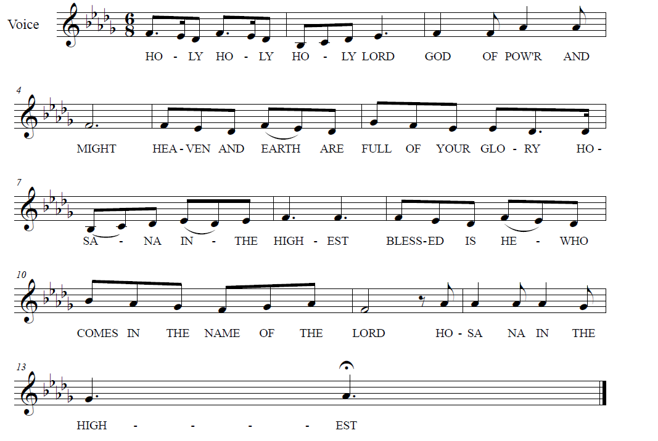

**

**↑ REMEMBERING THE WORDS OF INSTITUTION**

When Tree of Life celebrated Holy Communion last Sunday, we heard again the story of God’s mighty acts and of the love shown us in the death and resurrection of our Lord Jesus Christ. With thanksgiving we remembered that:

“In the night in which he was betrayed, our Lord Jesus took bread, and gave thanks; broke it, and gave it to his disciples, saying: Take and eat; this is my body, given for you. Do this for the remembrance of me.

“Again, after supper, he took the cup, gave thanks, and gave it for all to drink, saying: This cup is the new covenant in my blood, shed for you and for all people for the forgiveness of sin. Do this for the remembrance of me.”

We were given assurance of our Lord’s presence through the gift of his Holy Spirit. Now we share again this same bread of life and this same cup of blessing, that we may be strengthened through our participation in the body of Christ.

**↑ LORD’S PRAYER**

Lord, remember us in your Kingdom, and teach us always to pray:

**Our Father, who art in heaven, hallowed be thy name,**

**thy kingdom come, thy will be done, on earth as it is in heaven.**

**Give us this day our daily bread.**

**And forgive us our trespasses, as we forgive those who trespass against us.**

**And lead us not into temptation, but deliver us from evil.**

**For thine is the kingdom, and the power, and the glory, forever and ever. Amen.**

**↑ INVITATION TO COMMUNION**

The gifts of God for the people of God.

**Thanks be to God.**

*All baptized Christians are welcome to commune. Wine and white grape juice are in the individual cups. Gluten-free wafers are available upon request.*

**COMMUNION** *Composed by D.D. Dillard*

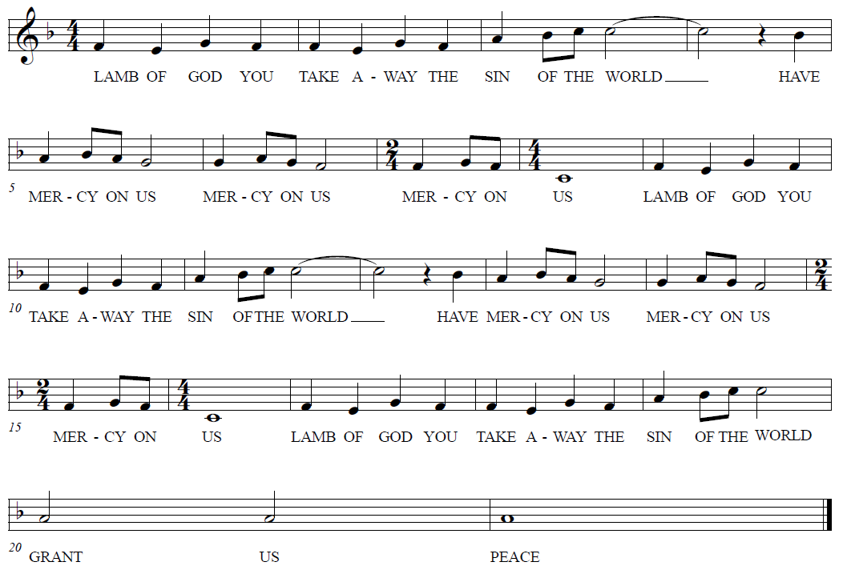

**HYMNS “Change My Heart, O God” BLACK BINDER #4**

**“Spirit Song” BLACK BINDER #6**

**↑ Prayer after Communion**

Let us pray together: **Holy Lord, you gathered us to your table, and we drank deeply of your grace. Send us out by your Spirit to love our neighbors as ourselves and proclaim your love in Jesus’ name. Amen.**

**↑ HYMN “This Little Light of Mine” RED HYMNAL #677**

**God Sends Us in Mission**

**Announcements**

**↑ Benediction**

The Lord bless you and keep you. The Lord’s face shine upon you and be gracious to you. The Lord look upon you with favor and ☩ give you peace. **Amen.**

**↑ HYMN** **“I Love to Tell the Story” RED HYMNAL #661**

**↑ MISSION STATEMENT**

What is our Mission? **To be faithful children of God, called by grace through Christ, and sharing this gift with Middletown, Odessa, Townsend and the World.**

**↑ Dismissal**

Go in peace; serve the Lord!

**Thanks be to God!**

**POSTLUDE**

*You may listen to the music or depart to do God’s work.*

*And the finale…*

**ICE CREAM SUNDAES!**

*Join us after worship!*

From Sundays and Seasons.com. Copyright 2025 Augsburg Fortress. All rights reserved.

Reprinted by permission under Augsburg Fortress Liturgies Annual License #28947.New Revised Standard Version Bible, copyright 1989, Division of Christian Education of the National Council of the Churches of Christ in the United States of America. Used by permission. All rights reserved.

**Rev. Yehiel Curry Elected ELCA Presiding Bishop**

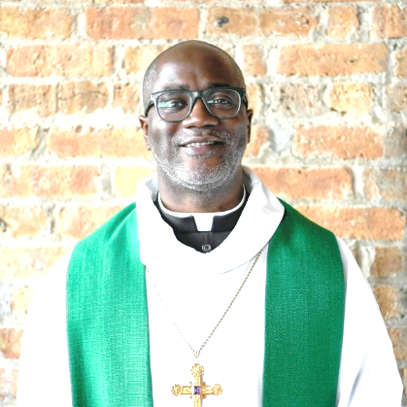

The Rev. Yehiel Curry has been elected as the next presiding bishop of the ELCA. Curry is currently the bishop of the Metropolitan Chicago Synod, and will be the first Black presiding bishop in the ELCA’s history. He was elected on Wednesday during the 2025 ELCA Churchwide Assembly, a triennial national gathering of clergy and lay leaders held last week in Phoenix, Ariz.

Curry was elected on the fifth ballot. There were 799 votes cast, with 400 votes needed for an election. Curry received 562 votes, and the Rev. Kevin Strickland, bishop of the Southeastern Synod, received 237 votes. The Rev. Bill Gohl, bishop of the Delaware-Maryland Synod, was among the final seven candidates for presiding bishop.

Curry has served as bishop of the Metropolitan Chicago Synod since 2019. He previously served as mission developer and pastor of Shekinah Chapel in Riverdale, Ill. A predominantly Black congregation in the South Side of Chicago, Shekinah began as a mission start in 1995 with an emphasis on social ministry.

Before ordained ministry, Curry was a seventh grade public school teacher and then a social worker. He grew up in the South Side of Chicago and was raised Roman Catholic. He received a Bachelor of Arts from Lewis University in Romeoville, Ill., in 1995 and a Master of Divinity from the Lutheran School of Theology at Chicago in 2013. Curry was ordained through the Theological Education for Emerging Ministries program, a different track from a four-year residential seminary degree that trains existing leaders from ethnic-specific, multicultural, rural and inner-city settings for ordained ministry.

Curry and his wife, LaShonda, have three daughters. His six-year term will begin in October. He will be the fifth presiding bishop in the ELCA’s history, succeeding the Rev. Elizabeth Eaton, who is retiring after two terms.

The presiding bishop is president and CEO of the ELCA and oversees the church’s national office. The presiding bishop chairs the Churchwide Assembly; helps craft agendas for the assembly, the ELCA Church Council and the ELCA Conference of Bishops; serves as chief ecumenical officer of the church; and provides leadership for the bishops of the ELCA’s 65 synods.

*- Excerpted ELCA press release, Religion News Service, ELCA websites*

**Upcoming Happenings**

**Sunday, August 10**

Blessing of the Backpacks

to support Appoquinimink students

**Sunday, August 24**

Worship with Sacrament of Holy Baptism

for Olivia Breighner Castelló

