**Welcome to Tree of Life Lutheran Church**

August 17, 2025 – Tenth Sunday After Pentecost

Leader in regular type, **congregation in bold type**

**↑** means stand as you are able

**Restrooms** are by the kitchen and by the Wiggle Room

**Wiggle Room** is available for anyone needing a brief break from worship, at the end of the piano wing of the sanctuary

**WiFi** is available: Look for TOL-GUEST; password is OdessaTOL1



**We Gather as God’s People**

**PRELUDE**

*You can use this time for quiet reflection, prayer and preparation for worship.*

**↑ CONFESSION AND FORGIVENESS**

In the name of the Father, and of the +Son, and of the Holy Spirit. **Amen.**

Baptized into Christ and trusting in his grace, let us confess our sins in the presence of God and one-another. *Silence for reflection.*

Most merciful God: **You free us to love others,** **but we neglect our neighbors and follow our own way.** **You lead us by the Spirit,** **but we turn to sin in our thoughts, words and deeds.** **You surround us with goodness, but we grow weary in doing what is right. For the sake of your Son Jesus Christ, forgive us.**

**Heal us and show us the path of life.** **Amen.**

You belong to Christ Jesus, and you are God’s children through faith. As a called and ordained minister of the church of Christ, and by his authority, I therefore declare to you the entire forgiveness of all your sins, in the name of the Father, and of the +Son, and of the Holy Spirit. **Amen.**

**↑ HYMN “My Hope Is Built On Nothing Less” RED HYMNAL #596**

**↑ APOSTOLIC GREETING**

The grace of our Lord Jesus Christ, the love of God, and the communion of the Holy Spirit be with you all. **And also with you.**

**↑ HYMN OF PRAISE “Lord, I Lift Your Name on High” ELW #857**

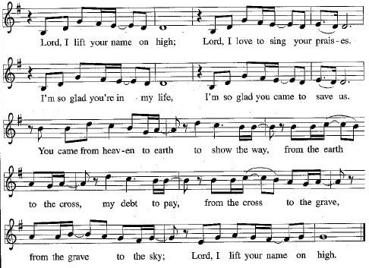

**↑ Prayer of the Day**

The Lord be with you. **And also with you.**

Let us pray: O God, judge eternal, you love justice and hate oppression, and you call us to share your zeal for truth. Give us courage to take our stand with all victims of bloodshed and greed, and, following your servants and prophets, to look to the pioneer and perfecter of our faith, your Son, Jesus Christ, our Savior and Lord. **Amen.**

**We Hear God’s Word**

**First Reading: Jeremiah 23:23-29**

A reading from Jeremiah:

23 Am I a God near by, says the Lord, and not a God far off? 24 Who can hide in secret places so that I cannot see them? says the Lord. Do I not fill heaven and earth? says the Lord. 25 I have heard what the prophets have said who prophesy lies in my name, saying, “I have dreamed! I have dreamed!” 26 How long? Will the hearts of the prophets ever turn back — those who prophesy lies and who prophesy the deceit of their own heart? 27 They plan to make my people forget my name by their dreams that they tell one another, just as their ancestors forgot my name for Baal. 28 Let the prophet who has a dream tell the dream, but let the one who has my word speak my word faithfully. What has straw in common with wheat? says the Lord. 29 Is not my word like fire, says the Lord, and like a hammer that breaks a rock in pieces?

The word of the Lord.

**Thanks be to God.**

**Psalm: Psalm 82**

1 God stands to charge the divine council assembled,  
  giving judgment in the midst of the gods:  
2 **“How long will you judge unjustly, and show favor to the wicked?**3 Save the weak and the orphan; defend the humble and needy;  
4**rescue the weak and the poor; deliver them from the power of the wicked.**5 They do not know, neither do they understand;

they wander about in darkness; all the foundations of the earth are shaken.  
6 **Now I say to you, ‘You are gods, and all of you children of the Most High;**7 nevertheless, you shall die like mortals, and fall like any prince.’ ”  
8 **Arise, O God, and rule the earth, for you shall take all nations for your own.**

**Second Reading: Hebrews 11:29-12:2**

A reading from Hebrews:

29 By faith the people passed through the Red Sea as if it were dry land, but when the Egyptians attempted to do so they were drowned. 30 By faith the walls of Jericho fell after they had been encircled for seven days. 31 By faith Rahab the prostitute did not perish with those who were disobedient, because she had received the spies in peace.  
   32And what more should I say? For time would fail me to tell of Gideon, Barak, Samson, Jephthah, of David and Samuel and the prophets, 33who through faith conquered kingdoms, administered justice, obtained promises, shut the mouths of lions, 34quenched the power of fire, escaped the edge of the sword, were made strong out of weakness, became mighty in war, put foreign armies to flight. 35Women received their dead by resurrection. Others were tortured, refusing to accept release, in order to obtain a better resurrection. 36Others suffered mocking and flogging and even chains and imprisonment. 37They were stoned to death; they were sawn in two; they were killed by the sword; they went about in skins of sheep and goats, destitute, persecuted, tormented, 38 of whom the world was not worthy. They wandered in deserts and mountains and in caves and holes in the ground.

39 Yet all these, though they were commended for their faith, did not receive what was promised, 40 since God had provided something better so that they would not, apart from us, be made perfect.

12:1Therefore, since we are surrounded by so great a cloud of witnesses, let us also lay aside every weight and the sin that clings so closely, and let us run with perseverance the race that is set before us, 2looking to Jesus, the pioneer and perfecter of faith, who for the sake of the joy that was set before him endured the cross, disregarding its shame, and has taken his seat at the right hand of the throne of God.

The word of the Lord.

**Thanks be to God.**

**↑ GOSPEL ACCLAMATION** *Composed by D.D. Dillard*

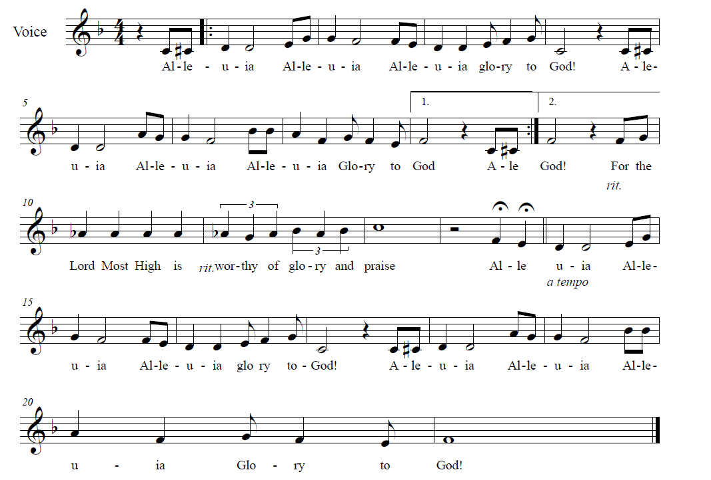



**↑** **GOSPEL: Luke 12:49-56**

The holy gospel according to Luke.

**Glory to you, O Lord.**

[Jesus said:] 49“I have come to cast fire upon the earth, and how I wish it were already ablaze! 50I have a baptism with which to be baptized, and what constraint I am under until it is completed! 51Do you think that I have come to bring peace to the earth? No, I tell you, but rather division! 52From now on five in one household will be divided, three against two and two against three; 53they will be divided: father against son and son against father, mother against daughter and daughter against mother, mother-in-law against her daughter-in-law and daughter-in-law against mother-in-law.”  
   54 He also said to the crowds, “When you see a cloud rising in the west, you immediately say, ‘It is going to rain,’ and so it happens. 55 And when you see the south wind blowing, you say, ‘There will be scorching heat,’ and it happens. 56 You hypocrites! You know how to interpret the appearance of earth and sky, but why do you not know how to interpret the present time?”

The gospel of the Lord.

**Praise to you, O Christ.**

**CHILDREN’S SERMON**

**Sermon**

**↑ HYMN “Lord Let My Heart Be Good Soil” RED HYMNAL #512**

**↑ APOSTLES’ CREED**

**I believe in God, the Father almighty, creator of heaven and earth.**

**I believe in Jesus Christ, his only Son, our Lord,**

**who was conceived by the Holy Spirit, born of the virgin Mary,**

**suffered under Pontius Pilate,** **was crucified, died, and was buried;**

**and descended into hell.**

**On the third day he rose again;** **he ascended into heaven,**

**he is seated at the right hand of the Father,**

**and he will come to judge the living and the dead.**

**I believe in the Holy Spirit,**

**the holy catholic Church,** **the communion of saints,**

**the forgiveness of sins,** **the resurrection of the body,**

**and the life everlasting. Amen.**

**↑ PRayers of Intercession**

By the power of the Holy Spirit, let us pray for the Church, the world, and all people according to their needs:

Almighty God and Father of all, you have given faith to your people throughout history. Continue to bestow your faith upon the Church around the world. Help us listen to the truth of your Word, and turn away from those who prophecy falsehood. Protect missionaries and any who are persecuted for the faith. God of grace…

**Hear our prayer.**

You entrust this world to our care. Bless the forests and the farmlands with bountiful growth. Be with any who suffer from heat, drought, storm or other natural disaster. Help us be good stewards of all you have made. God of grace… **Hear our prayer.**

You care for the weak and the orphan, the humble and the needy. Inspire us to care for the poor in our midst, and grant that all people might know freedom, justice and peace Send your righteousness and wisdom upon those who govern this and every nation. Protect all who serve for our protection. God of grace… **Hear our prayer.**

You hear those who cry out to you. Be with the sick, the weary, the grieving and all in any need. We especially pray for Annalise, Bill, Bob, Chris, Dan, Danielle, Dot, Elizabeth, Erika, Hanne-Lore, Patrick, Paul, Sarah, William, Winnie and those we name with our lips or in our hearts… *(Time for personal petitions)* God of grace…

**Hear our prayer.**

You give us strength to persevere in following the faith and the ways of your Son. Lead Tree of Life to witness to you, to serve our neighbor, and to bring new people into a deeper relationship with Jesus. Humble us by your Law, and comfort us with your Gospel. Bless our bishops, Elizabeth and William; our pastor, Robbie; Community Lutheran Church and its pastor, Karis; and Grace of God Community Church. God of grace… **Hear our prayer.**

Your Son endured the cross of sin and death in order to give us the joy of forgiveness and eternal life with you. Accept our thanksgiving for the cloud of witnesses whose earthly race is won. By the example of their faith, enable us to life in hope and love, until that day when we join their unending praise.  God of grace… **Hear our prayer.**

We lift up these and all our prayers to you, O Lord, in the name of Jesus Christ, our Savior and Lord. **Amen.**

**↑ Peace**

The peace of Christ be with you always***.* And also with you.**

**We Share God’s Holy Meal**

**↑ OFFERTORY RED HYMNAL #884**

**Praise God, from whom all blessings flow;**

**Praise Him, all creatures here below;**

**Praise Him above, ye Heav’nly host;**

**Praise Father, Son and Holy Ghost**

**↑ Offering Prayer**

Let us pray together: **Holy God, gracious and merciful, you bring forth food from the earth and nourish your whole creation. Turn our hearts toward those who hunger in any way, that all may know your care. Prepare us now to feast on the bread of life, Jesus Christ, our Savior and Lord. Amen.**

**↑ great thanksgiving**

*The thanksgiving continues with the preface for the day. The congregation responds:*

**↑ SANCTUS** *Composed by D.D. Dillard*

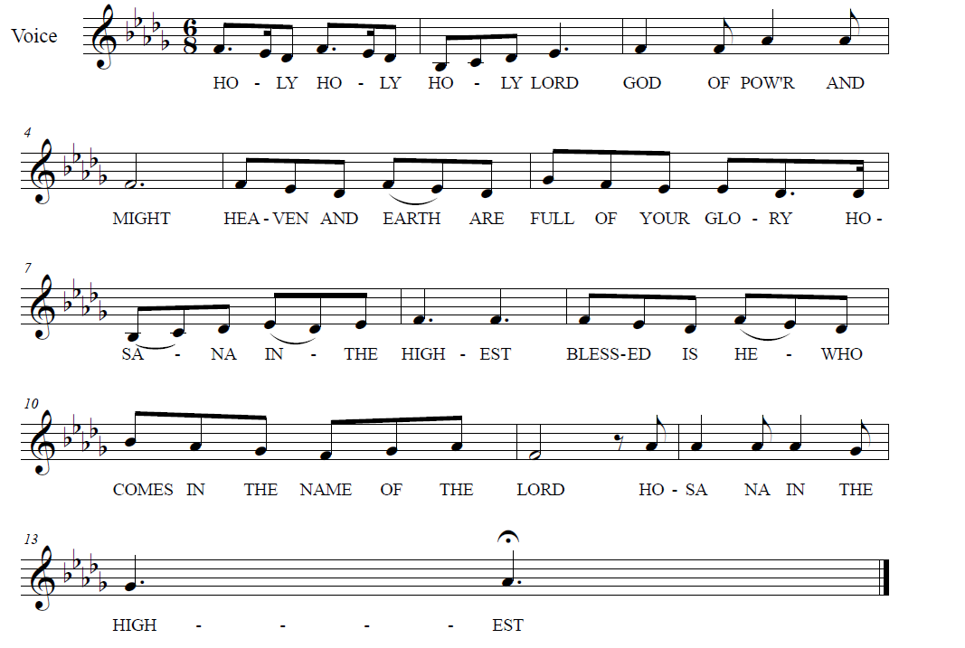

**

**↑ EUCHARISTIC PRAYER & WORDS OF INSTITUTION**

In the night in which he was betrayed, our Lord Jesus took bread, and gave thanks; broke it, and gave it to his disciples, saying: Take and eat; this is my body, given for you. Do this for the remembrance of me.

Again, after supper, he took the cup, gave thanks, and gave it for all to drink, saying: This cup is the new covenant in my blood, shed for you and for all people for the forgiveness of sin. Do this for the remembrance of me.

**↑ LORD’S PRAYER**

**Our Father, who art in heaven, hallowed be thy name,**

**thy kingdom come, thy will be done, on earth as it is in heaven.**

**Give us this day our daily bread.**

**And forgive us our trespasses, as we forgive those who trespass against us.**

**And lead us not into temptation, but deliver us from evil.**

**For thine is the kingdom, and the power, and the glory, forever and ever. Amen.**

**↑ INVITATION TO COMMUNION**

The gifts of God for the people of God.

**Thanks be to God.**

*All baptized Christians are welcome to commune. Wine and white grape juice are in the individual cups. Gluten-free wafers are available upon request.*

**COMMUNION** *Composed by D.D. Dillard*

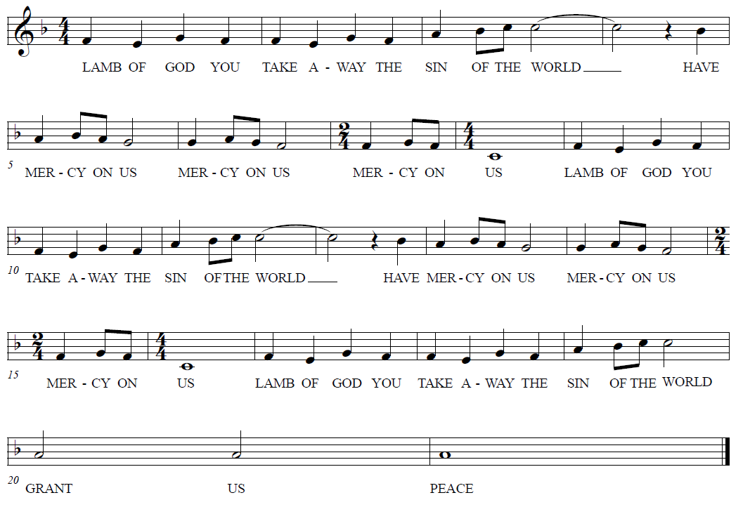

**HYMNS “Change My Heart O God” BLACK BINDER #4**

**“Spirit Song” BLACK BINDER #6**

**Prayer after Communion**

Let us pray together: **Holy Lord, you gathered us to your table, and we drank deeply of your grace. Send us out by your Spirit to love our neighbors as ourselves and proclaim your love in Jesus’ name. Amen.**

**God Sends Us in Mission**

**Announcements**

**↑ Benediction**

The Lord bless you and keep you. The Lord’s face shine upon you and be gracious to you. The Lord look upon you with favor and ☩ give you peace. **Amen.**

**↑ HYMN** **“God Be With You Til We Meet Again” RED HYMNAL #536**

**↑ MISSION STATEMENT**

What is our Mission? **To be faithful children of God, called by grace through Christ, and sharing this gift with Middletown, Odessa, Townsend and the World.**

**↑ Dismissal**

Go in peace; serve the Lord!

**Thanks be to God!**

**POSTLUDE**

*You may listen to the music or depart to do God’s work.*

*Please join us for refreshments in the fellowship room after the service.*

From Sundays and Seasons.com. Copyright 2025 Augsburg Fortress. All rights reserved.

Reprinted by permission under Augsburg Fortress Liturgies Annual License #28947.New Revised Standard Version Bible, copyright 1989, Division of Christian Education of the National Council of the Churches of Christ in the United States of America. Used by permission. All rights reserved.

**Upcoming Happenings**

**Sunday, August 24**

Worship with Sacrament of Holy Baptism

for Olivia Breighner Castelló

**Sunday, September 7**

Rally Day Worship

Blessing of Students and Teachers