**Welcome to Tree of Life Lutheran Church**

August 10, 2025 – Ninth Sunday After Pentecost

Leader in regular type, **congregation in bold type**

**↑** means stand as you are able

**Restrooms** are by the kitchen and by the Wiggle Room

**Wiggle Room** is available for anyone needing a brief break from worship, at the end of the piano wing of the sanctuary

**WiFi** is available: Look for TOL-GUEST; password is OdessaTOL1



**We Gather as God’s People**

**PRELUDE**

*You can use this time for quiet reflection, prayer and preparation for worship.*

**↑ CONFESSION AND FORGIVENESS**

In the name of the Father, and of the +Son, and of the Holy Spirit. **Amen.**

Baptized into Christ and trusting in his grace, let us confess our sins in the presence of God and one-another. *Silence for reflection.*

Most merciful God: **You free us to love others,** **but we neglect our neighbors and follow our own way.** **You lead us by the Spirit,** **but we turn to sin in our thoughts, words and deeds.** **You surround us with goodness, but we grow weary in doing what is right. For the sake of your Son Jesus Christ, forgive us.**

**Heal us and show us the path of life.** **Amen.**

You belong to Christ Jesus, and you are God’s children through faith. As a called and ordained minister of the church of Christ, and by his authority, I therefore declare to you the entire forgiveness of all your sins, in the name of the Father, and of the +Son, and of the Holy Spirit. **Amen.**

**↑ HYMN “Have No Fear Little Flock” RED HYMNAL #764**

**↑ APOSTOLIC GREETING**

The grace of our Lord Jesus Christ, the love of God, and the communion of the Holy Spirit be with you all. **And also with you.**

**↑ HYMN OF PRAISE “Lord, I Lift Your Name on High” ELW #857**

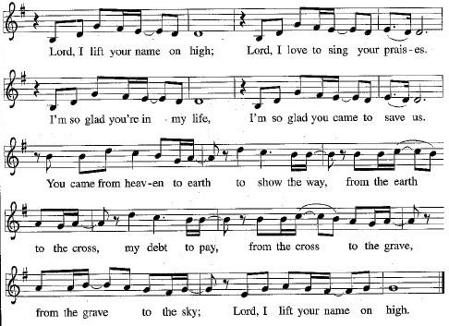

**↑ Prayer of the Day**

The Lord be with you. **And also with you.**

Let us pray: Almighty God, you sent your Holy Spirit to be the life and light of your church. Open our hearts to the riches of your grace, that we may be ready to receive you wherever you appear, through Jesus Christ, our Savior and Lord. **Amen.**

**We Hear God’s Word**

**First Reading: Genesis 15:1-6**

A reading from Genesis:

1 After these things the word of the Lord came to Abram in a vision, “Do not be afraid, Abram, I am your shield; your reward shall be very great.” 2 But Abram said, “O Lord God, what will you give me, for I continue childless, and the heir of my house is Eliezer of Damascus?” 3 And Abram said, “You have given me no offspring, so a slave born in my house is to be my heir.”

4 But the word of the Lord came to him, “This man shall not be your heir; no one but your very own issue shall be your heir.” 5 He brought him outside and said, “Look toward heaven and count the stars, if you are able to count them.” Then he said to him, “So shall your descendants be.” 6 And he believed the Lord, and the Lord reckoned it to him as righteousness.

The word of the Lord.

**Thanks be to God.**

**Psalm: Psalm 33:12-22**

12 Happy is the nation whose God is the Lord!  
  Happy the people chosen to be God’s heritage!13**The Lord looks down from heaven, and sees all humankind.**14 God sits firmly enthroned and watches all who dwell on the earth.  
15**God fashions all their hearts and observes all their deeds.** 16 A king is not saved by the size of the army,  
  nor are warriors rescued by their great strength.  
17**The horse gives vain hope for victory;  
   despite its great strength it cannot save.** 18 Truly, your eye is upon those who fear you, O Lord,  
   upon those who wait for your steadfast love,  
19**to deliver their lives from death, and to keep them alive in time of famine.** 20 Our innermost being waits for you, O Lord, our helper and our shield.  
21 **Surely, our heart rejoices in you, for in your holy name we put our trust.  
  22 Let your lovingkindness, O Lord, be upon us,  
   even as we place our hope in you.**

**Second Reading: Hebrews 11:1-3, 8-16**

A reading from Hebrews:

1 Now faith is the assurance of things hoped for, the conviction of things not seen. 2 Indeed, by faith our ancestors received approval. 3 By faith we understand that the worlds were prepared by the word of God, so that what is seen was made from things that are not visible.  
   8 By faith Abraham obeyed when he was called to set out for a place that he was to receive as an inheritance, and he set out, not knowing where he was going. 9 By faith he stayed for a time in the land he had been promised, as in a foreign land, living in tents, as did Isaac and Jacob, who were heirs with him of the same promise. 10 For he looked forward to the city that has foundations, whose architect and builder is God. 11 By faith, with Sarah’s involvement, he received power of procreation, even though he was too old, because he considered him faithful who had promised. 12 Therefore from one person, and this one as good as dead, descendants were born, “as many as the stars of heaven and as the innumerable grains of sand by the seashore.”  
   13 All of these died in faith without having received the promises, but from a distance they saw and greeted them. They confessed that they were strangers and foreigners on the earth, 14 for people who speak in this way make it clear that they are seeking a homeland. 15 If they had been thinking of the land that they had left behind, they would have had opportunity to return. 16 But as it is, they desire a better homeland, that is, a heavenly one. Therefore God is not ashamed to be called their God; indeed, he has prepared a city for them.

The word of the Lord.

**Thanks be to God.**

**↑ GOSPEL ACCLAMATION** *Composed by D.D. Dillard*

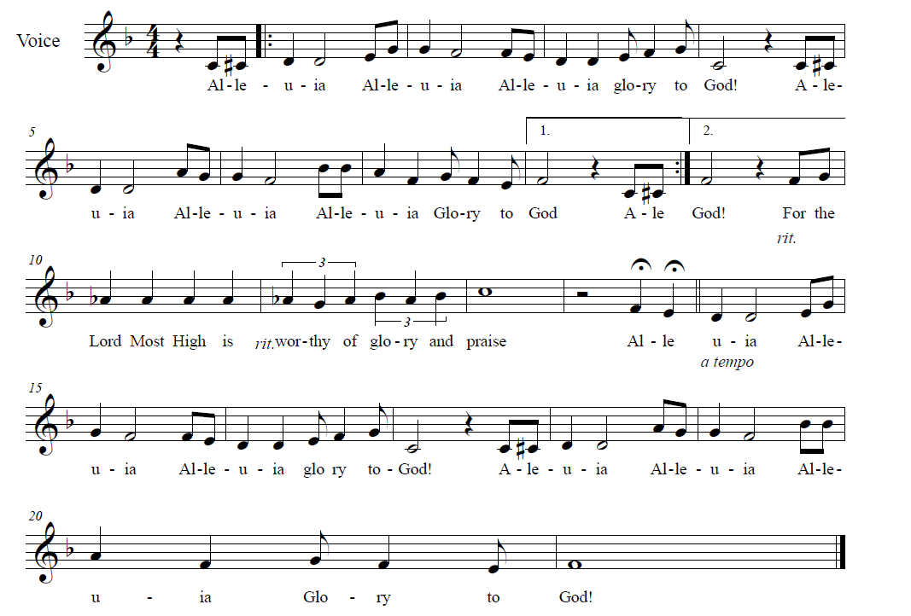



**↑** **GOSPEL: Luke 12:32-40**

The holy gospel according to Luke.

**Glory to you, O Lord.**

[Jesus said:] 32 “Do not be afraid, little flock, for it is your Father’s good pleasure to give you the kingdom. 33 Sell your possessions and give alms. Make purses for yourselves that do not wear out, an unfailing treasure in heaven, where no thief comes near and no moth destroys. 34 For where your treasure is, there your heart will be also.  
   35 “Be dressed for action and have your lamps lit; 36 be like those who are waiting for their master to return from the wedding banquet, so that they may open the door for him as soon as he comes and knocks. 37 Blessed are those slaves whom the master finds alert when he comes; truly I tell you, he will fasten his belt and have them sit down to eat, and he will come and serve them. 38 If he comes during the middle of the night or near dawn and finds them so, blessed are those slaves.  
  39 “But know this: if the owner of the house had known at what hour the thief was coming, he would not have let his house be broken into. 40 You also must be ready, for the Son of Man is coming at an hour you do not expect.”

The gospel of the Lord.

**Praise to you, O Christ.**

**CHILDREN’S SERMON**

**Sermon**

**↑ HYMN “Let Us Ever Walk With Jesus” RED HYMNAL #802**

**↑ BLESSING OF BACKPACKS**

Dear friends in Christ: Today we give thanks to God and seek God’s blessing, as we bless these backpacks and school supplies that have been donated for students in need in our area.

*A brief description may follow*

Let us pray: Blessed are you, O Lord our God, King of the universe. You made the whole earth for your glory; all creation praises you. We give you thanks, O God,

as we set apart these school supplies for the welfare of students in our community. Bless these backpacks, and the children who will wear them. Bless students with eagerness to learn, happiness when learning is easy, and perseverance when learning is hard. Inspire us to serve those in need, until the day comes when need is no more. All this we pray in the name of your Son, Jesus Christ our Lord. Amen.

These school supplies, and those still to be collected, are now set apart for God’s work, in the name of the Father, and the +Son, and the Holy Spirit. Amen.

**↑ PRayers of Intercession**

By the power of the Holy Spirit, let us pray for the Church, the world, and all people according to their needs:

Faithful Lord, you are with us throughout our earthly journeys. Bring steadfastness and faithfulness to your Church in all times and places. Remind us of your presence in times of hardship, make us grateful in times of joy, and help us set our hearts on you as our greatest treasure. God of grace… **Hear our prayer.**

You created the stars of heaven, the sands of the seashore and the lilies of the field. Provide for every living thing amidst midsummer’s heat. Help anyone affected by storm, drought or natural disaster. Make us good stewards of the world you have entrusted to our care. God of grace… **Hear our prayer.**

Your majesty is greater than any earthly army. Lead our nation to follow your ways of freedom, justice and peace. Help us turn away from the idols of warfare, prejudice and earthly might, and instead place our trust and hope in you. God of grace…

**Hear our prayer.**

You watch over us and provide for our needs. Be with travelers and wanderers, the homeless and the hopeless, strangers and newcomers in our land, and anyone with needs of body, mind or spirit. We especially pray for Annalise, Bill, Bob, Chris, Dan, Danielle, Dot, Elizabeth, Erika, Patrick, Paul, Sarah, William, Winnie and those we name with our lips or in our hearts… *(Time for personal petitions)* God of grace… **Hear our prayer.**

You make Tree of Life your little flock, and you give us treasure beyond compare. Bless us with faithful hearts, kindly spirits, and charitable deeds. Remind us that our treasures are not found in buildings or bank accounts, but in your salvation and life. Bless our bishops, Elizabeth and William; our pastor, Robbie; Bethel Evangelical Lutheran Church and its pastor, Zach; and Unity Church and its pastors, Melissa and Brian. God of grace… **Hear our prayer.**

You have prepared a new city for us, a heavenly homeland where no thief comes near and no moth destroys. Accept our thanksgiving for those who lived by faith on earth and now rest in your glory. Sustain us in the sure hope of our resurrection to everlasting life. God of grace… **Hear our prayer.**

We lift up these and all our prayers to you, O Lord, in the name of Jesus Christ, our Savior and Lord. **Amen.**

**↑ Peace**

The peace of Christ be with you always***.* And also with you.**

**We Share God’s Holy Meal**

**↑ OFFERTORY RED HYMNAL #884**

**Praise God, from whom all blessings flow;**

**Praise Him, all creatures here below;**

**Praise Him above, ye Heav’nly host;**

**Praise Father, Son and Holy Ghost**

**↑ Offering Prayer**

Let us pray together: **Holy God, gracious and merciful, you bring forth food from the earth and nourish your whole creation. Turn our hearts toward those who hunger in any way, that all may know your care. Prepare us now to feast on the bread of life, Jesus Christ, our Savior and Lord. Amen.**

**↑ great thanksgiving**

*The thanksgiving continues with the preface for the day. The congregation responds:*

**↑ SANCTUS** *Composed by D.D. Dillard*

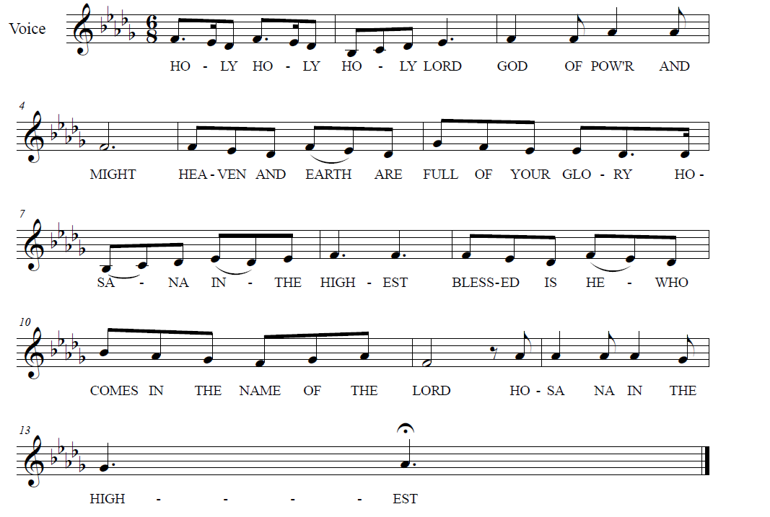

**

**↑ EUCHARISTIC PRAYER & WORDS OF INSTITUTION**

In the night in which he was betrayed, our Lord Jesus took bread, and gave thanks; broke it, and gave it to his disciples, saying: Take and eat; this is my body, given for you. Do this for the remembrance of me.

Again, after supper, he took the cup, gave thanks, and gave it for all to drink, saying: This cup is the new covenant in my blood, shed for you and for all people for the forgiveness of sin. Do this for the remembrance of me.

**↑ LORD’S PRAYER**

**Our Father, who art in heaven, hallowed be thy name,**

**thy kingdom come, thy will be done, on earth as it is in heaven.**

**Give us this day our daily bread.**

**And forgive us our trespasses, as we forgive those who trespass against us.**

**And lead us not into temptation, but deliver us from evil.**

**For thine is the kingdom, and the power, and the glory, forever and ever. Amen.**

**↑ INVITATION TO COMMUNION**

The gifts of God for the people of God.

**Thanks be to God.**

*All baptized Christians are welcome to commune. Wine and white grape juice are in the individual cups. Gluten-free wafers are available upon request.*

**COMMUNION** *Composed by D.D. Dillard*

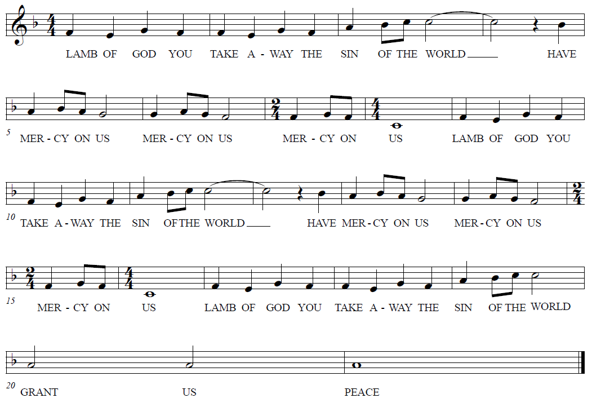

**HYMNS “Change My Heart O God” BLACK BINDER #4**

**“Spirit Song” BLACK BINDER #6**

**Prayer after Communion**

Let us pray together: **Holy Lord, you gathered us to your table, and we drank deeply of your grace. Send us out by your Spirit to love our neighbors as ourselves and proclaim your love in Jesus’ name. Amen.**

**God Sends Us in Mission**

**Announcements**

**↑ Benediction**

The Lord bless you and keep you. The Lord’s face shine upon you and be gracious to you. The Lord look upon you with favor and ☩ give you peace. **Amen.**

**↑ HYMN** **“I’m So Glad Jesus Lifted Me” RED HYMNAL #860**

**↑ MISSION STATEMENT**

What is our Mission? **To be faithful children of God, called by grace through Christ, and sharing this gift with Middletown, Odessa, Townsend and the World.**

**↑ Dismissal**

Go in peace; serve the Lord!

**Thanks be to God!**

**POSTLUDE**

*You may listen to the music or depart to do God’s work.*

*Please join us for refreshments in the fellowship room after the service.*

From Sundays and Seasons.com. Copyright 2025 Augsburg Fortress. All rights reserved.

Reprinted by permission under Augsburg Fortress Liturgies Annual License #28947.New Revised Standard Version Bible, copyright 1989, Division of Christian Education of the National Council of the Churches of Christ in the United States of America. Used by permission. All rights reserved.

**Upcoming Happenings**

**Thursday, August 14**

OWLS (Older Wiser Lutheran Seniors) Lunch

PF Chang’s, Christiana Mall

**Sunday, August 24**

Worship with Sacrament of Holy Baptism

for Olivia Breighner Castelló

**Saturday, September 6**

Progressive Dinner:

Different Servings at Members’ Homes

**Sunday, September 7**

Rally Day Worship

Blessing of Students and Teachers